Algebra 1: Unit 6, Lesson 7

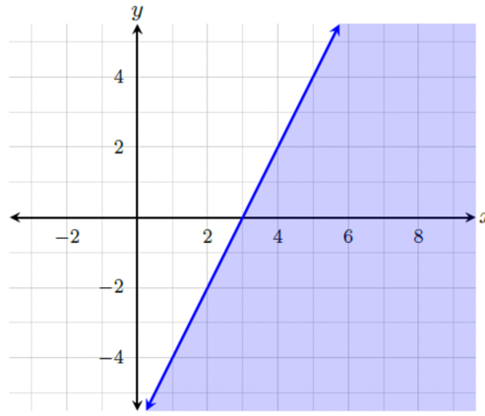
- The graph of $y≤2x-6$ is shown.

The coordinate $(1,5)$ ______________ a solution to the inequality $y≤2x-6$ .
is not

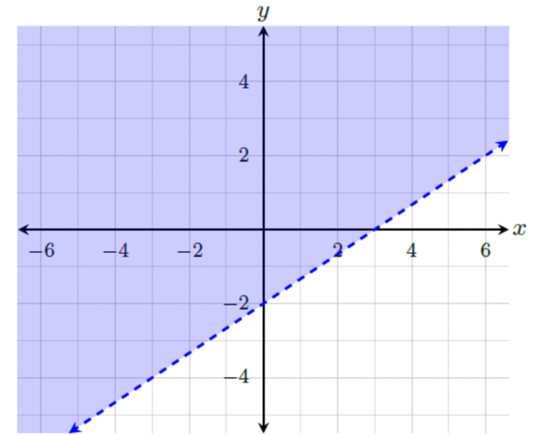
- The graph of the solution set of $2x-3y<6$ is shown.
Equivalent inequalities have the same solution set. What is the equation of the inequality in slope-intercept form?
$$y>\frac{2}{3}x-2$$

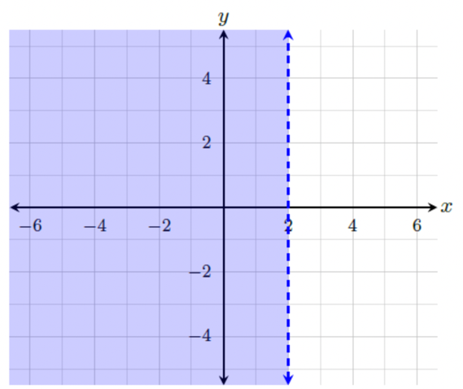
- A graph of an inequality is shown.

What is the inequality that represents the solution set represented by the graph?
$$x<2$$

